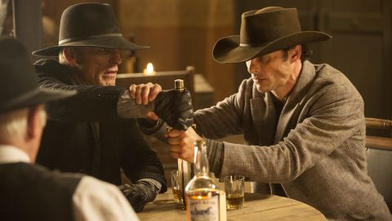

December 06, 2016

WESTWORLD SEASON 1: "SOME OF THE MOST POLISHED, SMARTEST TV YOU’LL EVER WATCH"
By Andy Hartup December 06, 2016

Westworld plays you. It plays you as assuredly as the skeletal fingers that dance across the piano keys in the title sequence. Each episode draws you in and seduces you with the promise of revelations, before flipping those expectations on their head and delivering something more interesting and finely crafted than you’d thought possible.

Not only that, though, Westworld’s episodes subtly seed persistent narrative elements that coalesce when the show is ready to reveal its secrets to the viewer. In terms of world, character, and story-building there has been nothing aired in 2016 that comes close to this season’s craft. In other words: it’s really, really good. Go watch it.

As with some of the best TV of recent years, Westworld draws on a rather unusual source to tell a story that feels pleasingly unique and exciting. It takes some vision to reimagine a movie from 1973, which is sort of about cowboys, but also about robots, and - whisper it - isn’t all that great. What this is, essentially, is robots going bad in a Western-themed park, where the wealthy elite holiday to blow off steam and indulge their base instincts.

That such a project would draw the attention of Anthony Hopkins, Ed Harris, and a whole host (haha) of up and coming talent from across Hollywood and beyond speaks to the strength of the original pitch, and a script that’s as intricately designed as the park’s inhabitants themselves.

The end result, however, is some of the most polished, smartest TV you’ll ever watch. More than that, Westworld does that rarest of things and mixes excellent dialogue, restrained acting, daring set-pieces, and superb CG without overplaying any of them. The star of the show is undoubtedly Hopkins, whose portrayal of Robert Ford is one of the most assured performances of his career. And this is Ford’s show. Everything that happens in Westworld S1 does so according to his design and will. While there are moments mid-season where we question whether or not the park’s co-creator is losing control, the climactic set of episodes put that notion firmly to bed and reveal the truth about the world we thought we knew. Each twist happens because he’s willed it, in some way. Even the mid-season awakening of Thandie Newton’s brilliant Maeve is all part of Ford’s plan, as we realise that her escape is all part of a narrative implanted in her by - you guessed it - Ford himself.
It’s tough to imagine anyone other than Hopkins handling the role of Ford. His delivery and expressions are all carefully calculated to let you know exactly what sort of man he is, without giving anything away that he doesn’t want you to know. As with any master manipulator we discover things only when Ford / Hopkins wants us to. While theorists can piece together clues and guess at the revelations of later episodes, it’s only when Ford confirms them that we truly know. He’s a remarkable character, and worth the price of admission alone.
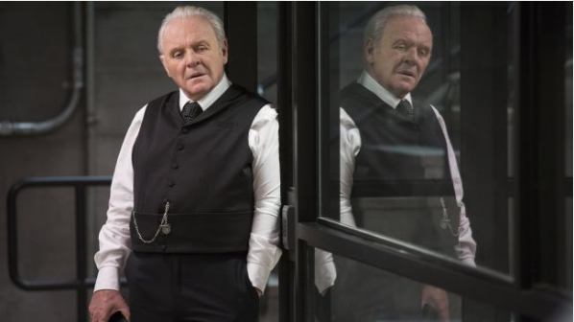
He’s the perfect pivot for the rest of the show, which veers quickly from action adventure, to romance, to sci-fi thriller, to mystery, to tragedy, and even dips its toe into horror. Few other TV seasons can boast such a variety of genres and styles, all carefully brought together and delivered with such panache. The heist sequences in Sweetwater are genuinely thrilling, William’s love story with Dolores both touching and heartbreaking, and the morality of Ford remains a mystery throughout the season (and beyond, because I’m still not sure you could call him either ‘good’ or ‘bad’). Even Ed Harris’ Man in Black takes the viewer through a range of emotions, from revulsion to redemption and - in the end - even pity. There are so many stories and individual moments to love here.
It’s not just an emotional journey - there’s plenty of thinking to be done too. Early episodes in the season leave enough breadcrumbs for story theorists to follow, but the show never gives away its answers before it’s ready. Yes, there’s a tremendous satisfaction in guessing what happens next, but very, very few will ever understand the extent of twists until they’re already in motion. As a piece of engaging TV, Westworld ticks a whole lot of boxes.

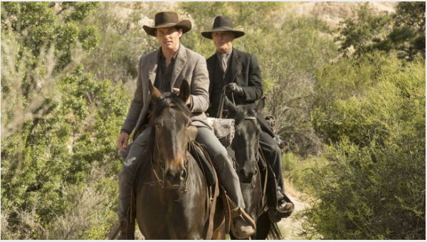
In fact, it’s tricky to truly summarise the extent of the show. As a piece of entertainment, it’s first class, but as a think-piece it’s a great watch too. Most of its core questions remain unanswered at the end of the season, and it’s up to the viewers to make up their own minds. Is Westworld’s park morally wrong? If a Host achieves true consciousness, are they truly alive? Are humans really the bad guys in Westworld? And where the hell is the show actually set? Is it even on earth? It’s a testament to the themes and delivery of them that people are still talking excitedly about Westworld and will likely continue until season starts in 2018.
It’s no surprise that Westworld has already been granted a second season, although following a character like Ford in a setting as rich and unique as Westworld itself is… an unenviable task. Expect reinvention rather than continuation because anything else would feel decidedly flat after this outstanding opening season. If you haven’t watched Westworld yet then you owe it to yourself to give it a try. While the season seems deliberately full of its own smarts at the start, the true brilliance is all revealed by the end, and the payoff is well worth a few head-scratching moments half way through.
And if you’ve already seen the whole season? You’re probably keen to rewatch it to pick up on all the narrative subtleties that lead to that finale. Because you’ve been played, and you need to understand how it all happened. Honestly, there are worse ways to spend ten hours of your life. Far worse.

